OS Installation and Initial Configurations for Raspberry Pi
Created by: Lochana Marasinghe

Stereo pi pinout: https://stereopi.com/blog/synchronizing-photos-two-stereopi-boards
- Install Raspberry Pi Bullseye (Raspbian GNU/Linux 11 (bullseye)) with armv7l architecture
- The following configurations were initially set.
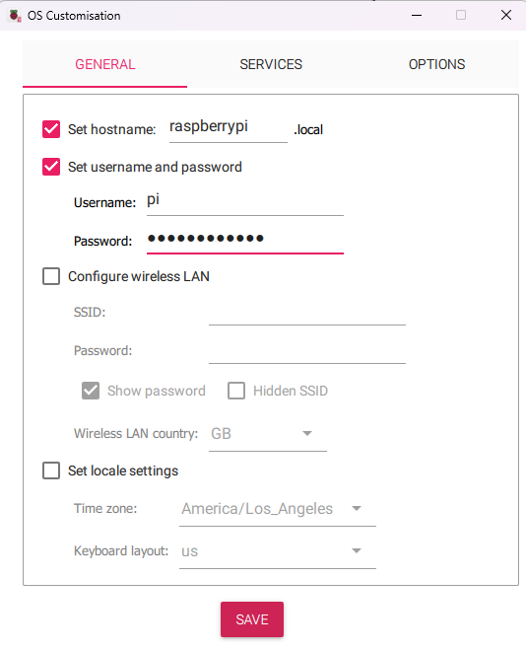
For each Raspberry Pi, this was continued.

- Connect the network cable from your PC to the Raspberry Pi and connect it via PuTTY
Connect your PC to Wi-Fi and enable the sharing of the network for other connected devices,
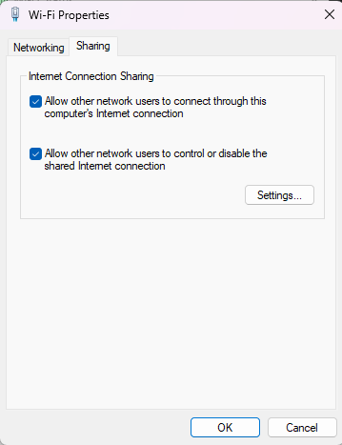

Python version: Python 3.9.2
- Run
sudo raspi-config
- Enable camera,i2c,SSH,OpenGL,SPI
- Change the timezone to America>vancouver
- Run sudo reboot
- Connect again via SSH
- Check the date using date command
- Start VNC server
vncserver-virtual
- For the pi cameras put the dt-blob.bin file to the /BOOT folder.
sudo mv /home/pi/Desktop/dt-blob.bin /boot

- Make sure you have an internet connection in raspberry pi. You can use the command below to check.
curl https://linuxconfig.org

- Install open cv
sudo apt-get -y install ca-certificates
sudo apt-get update
sudo apt-get install build-essential cmake pkg-config libjpeg-dev libtiff5-dev libjasper-dev libpng-dev libavcodec-dev libavformat-dev libswscale-dev libv4l-dev libxvidcore-dev libx264-dev libfontconfig1-dev libcairo2-dev libgdk-pixbuf2.0-dev libpango1.0-dev libgtk2.0-dev libgtk-3-dev libatlas-base-dev gfortran libhdf5-dev libhdf5-serial-dev libhdf5-103 python3-pyqt5 python3-dev -y

sudo apt-get install python3-opencv

- Install i2c tools
sudo apt-get install -y i2c-tools

i2cdetect -y 1
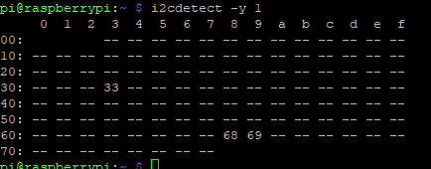

- Thermal sensor

sudo apt-get install libatlas-base-dev python-smbus

To increase your baud rate, sudo nano /boot/config.txt and find the line with dtparam=i2c_arm=on. Add i2c_arm_baudrate=400000 to the end of it, so the result should look like:
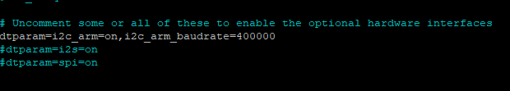

- Run sudo reboot
- Check again if the thermal sensor is connected using i2cdetect -y 1
- Install picamera library
sudo pip3 install picamera

Pass --break-system-packages flag:
If you want to ignore the warning, you can pass the --break-system-packages flag:
Ex: pip install --break-system-packages --user <foobar>

- Run this and install the library for the thermal sensor
sudo pip3 install pithermalcam --no-deps
sudo apt install python3-matplotlib
sudo apt-get install python3-scipy
sudo pip3 install RPi.GPIO --no-deps
sudo pip3 install Adafruit-Blinka
sudo pip3 install adafruit-circuitpython-mlx90640==1.3.1
sudo pip3 install cmapy --no-deps

If an older version of numpy is already installed, remove it and install the new version.
sudo apt remove python3-numpy
sudo apt install libatlas3-base
sudo pip3 install numpy==1.16.5
- Modify the pi_therm_cam.py as below.

sudo nano /usr/local/lib/python3.9/dist-packages/pithermalcam/pi_therm_cam.py
Add this in line after the get_mean_temp() function

def get_raw_mlx_temp_values(self):
"""
Get temp of entire field of view
"""
frame = np.zeros((24*32,)) # setup array for storing all 768 temperatures
while True:
try:
self.mlx.getFrame(frame) # read MLX temperatures into frame var
break
except ValueError:
continue # if error, just read again
return frame

Add “return fname” line at the end of the save_image() function.
def save_image(self):
"""Save the current frame as a snapshot to the output folder."""
fname = self.output_folder + 'pic_' + dt.datetime.now().strftime('%Y-%m-%d_%H-%M-%S') + '.jpg'
cv2.imwrite(fname, self._image)
self._file_saved_notification_start = time.monotonic()
print('Thermal Image ', fname)
return fname

Then add this row to the config.txt file:
enable_uart=1
Check if the cameras are detected
vcgencmd get_camera

- Install witty pi
wget https://www.uugear.com/repo/WittyPi3/install.sh
sudo sh install.sh

Install WiringPi
sudo apt-get install git-core
git clone https://github.com/WiringPi/WiringPi.git
cd WiringPi
git pull origin
./build
gpio -v

- Set up wi-fi on the mobile hotspot to auto-connect:

sudo nano /etc/wpa_supplicant/wpa_supplicant.conf
Add the lines below with your mobile hotspot credentials

network={
ssid="<enter_network_name>"
psk="<enter_password_for_the_network>"
key_mgmt=WPA-PSK
}

- Add this at the end of the cam_run.py and save
os.system("sudo shutdown -h now")
- Permit all to the code folder:
sudo chmod -R 777 <directory>

- Edit crontab to schedule running the capturing script.

Open cron tab: sudo crontab -e
Add this to the crontab
0 10,13,15 * * * python3 /home/pi/Documents/camera_run.py >> /home/pi/Documents/camera_run_cronjob.log 2>&1
Logs will be saved in /home/pi/Documents/camera_run_cronjob.log

Enable cron logging: sudo nano /etc/rsyslog.conf
Uncomment the line:
# cron.* /var/log/cron.log

Then, restart the rsyslog service: sudo /etc/init.d/rsyslog restart
Check logs in: /var/log/cron.log
- Edit Witty Pi configurations of each Raspberry Pi

Open witty pi configurations and reset data

cd wittypi/
sudo ./wittyPi.sh

Enter 10 then 1
Enter 10 then 2

Enter 6 and then 5
Enter 11 to exit configuration

Edit schedule.wpi

sudo nano schedule.wpi

Erase all and paste this (Refer to the power_and_cloud_upload_schedule_2024.txt to see the schedules for each Raspberry Pi camera setup)

BEGIN 2025-03-31 09:30:00
END 2035-07-31 23:59:59
ON M5 # keep ON state for 5 minutes for warm up (until 09:35)
OFF M15 # keep OFF state for 15 minutes (until 09:50)
ON M20 # keep ON state for 20 minutes (until 10:10)
OFF H2 M40 # keep OFF state for 2 hours 40 minutes (until 12:50)
ON M20 # keep ON state for 20 minutes (until 13:10)
OFF H1 M40 # keep OFF state for 1 hours 40 minutes (until 14:50)
ON M20 # keep ON state for 20 minutes (until 15:10)
OFF H18 M20 # keep OFF state for 18 hours 40 minutes (until 09:30 next day)

Close and save it. Then run the schedule.

sudo ./runScript.sh

Check if it’s the correct date and time for the next shutdown and startup

- Shutdown
sudo shutdown -h now

